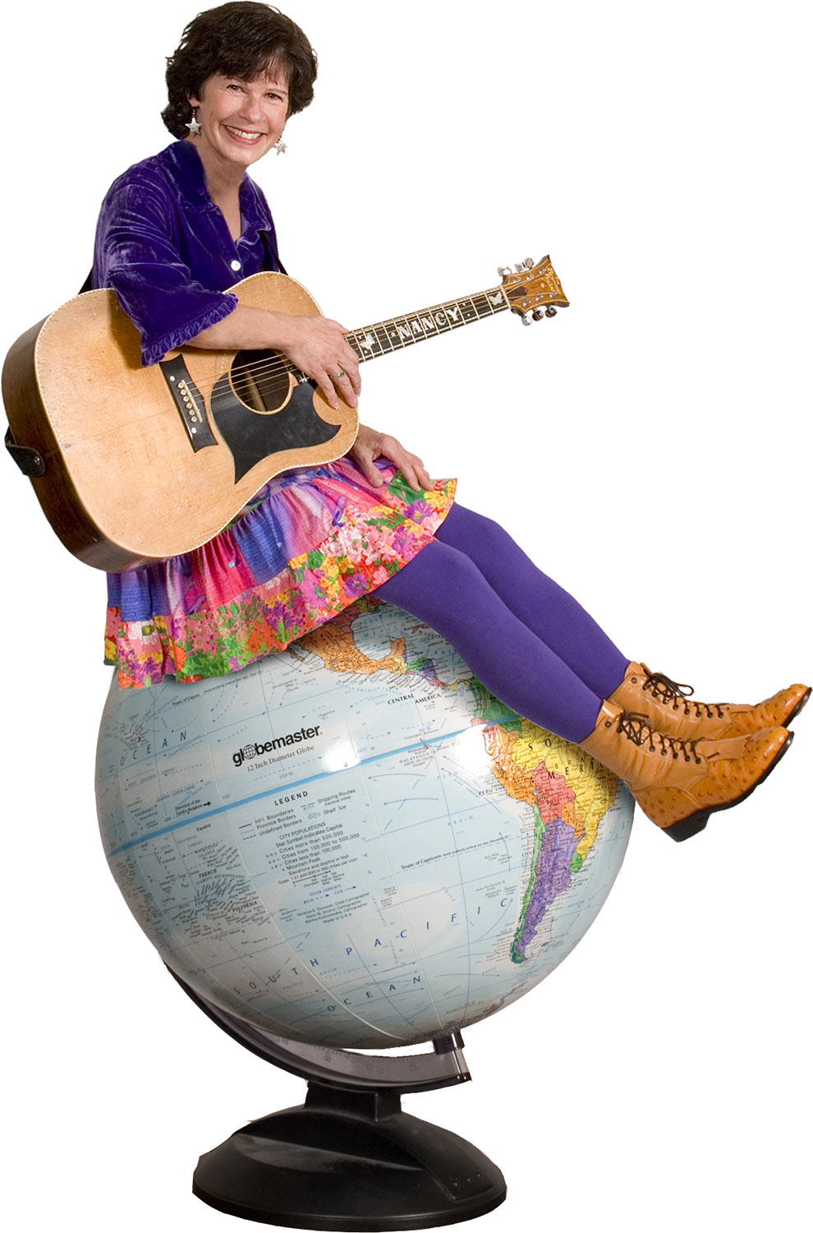
dinosaurs? volcanoes? vibrations? diamonds?
Where in the World?
Follow the Clues Concert with Nancy Stewart
Click here to type in location
Date &
time

www.Nancymusic.com

