Sing into Reading!

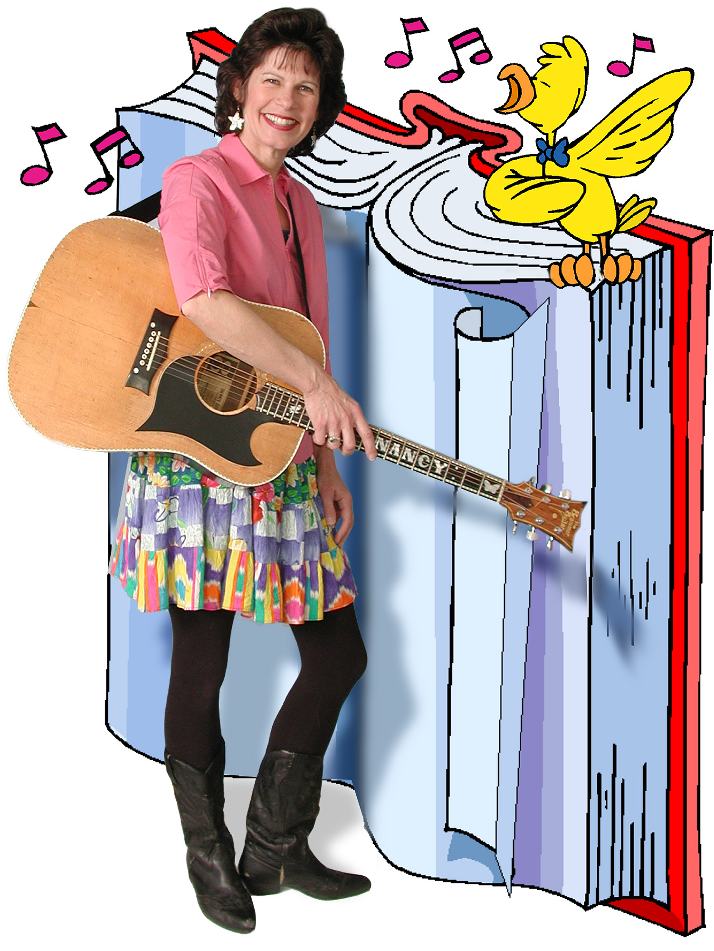

Family Concert with Nancy Stewart
(Type your concert details here)
www.Nancymusic.com
Family Concert!
Click here to type in date, time, and location.

