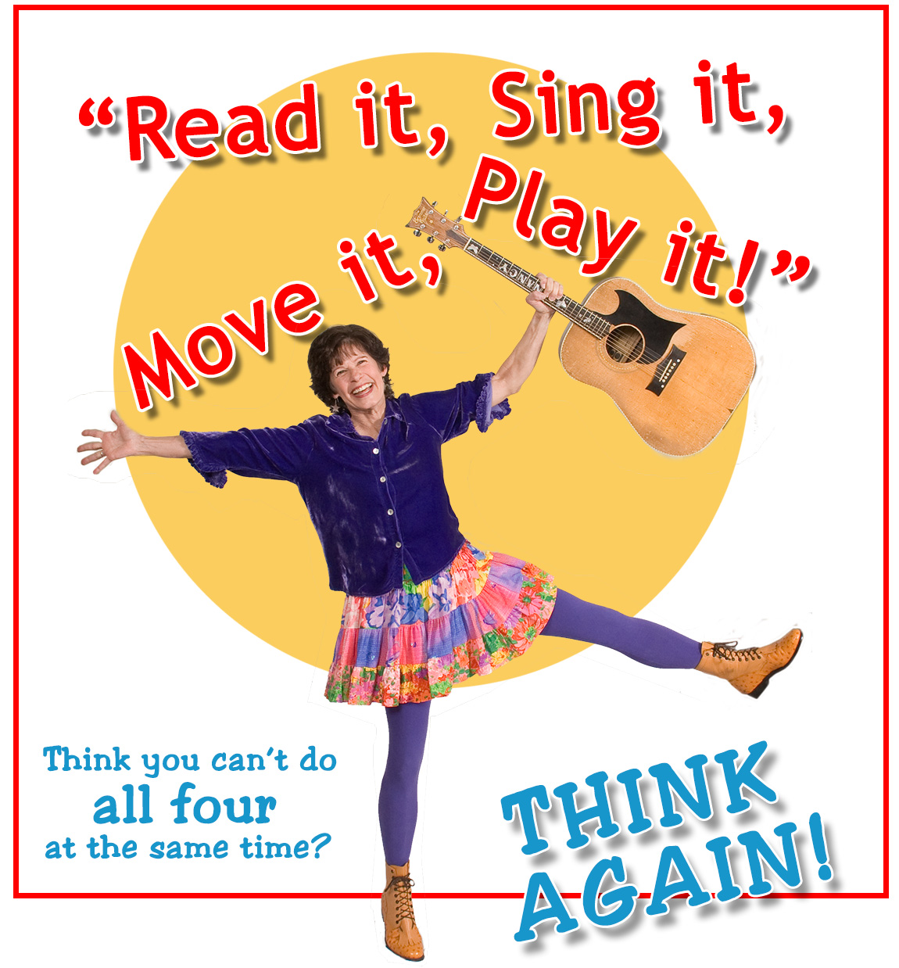

Join Northwest singer-songwriter Nancy Stewart as she shows you how, using tongue-twisting, brain-building, jump-it-up, silly songs and singing games.
Then download all the free songs and activities to continue the fun at home!
WHERE: __________________________________
DATE: ____________________ TIME:_________

