Family Concert!
Click here to type in date, time, and location.
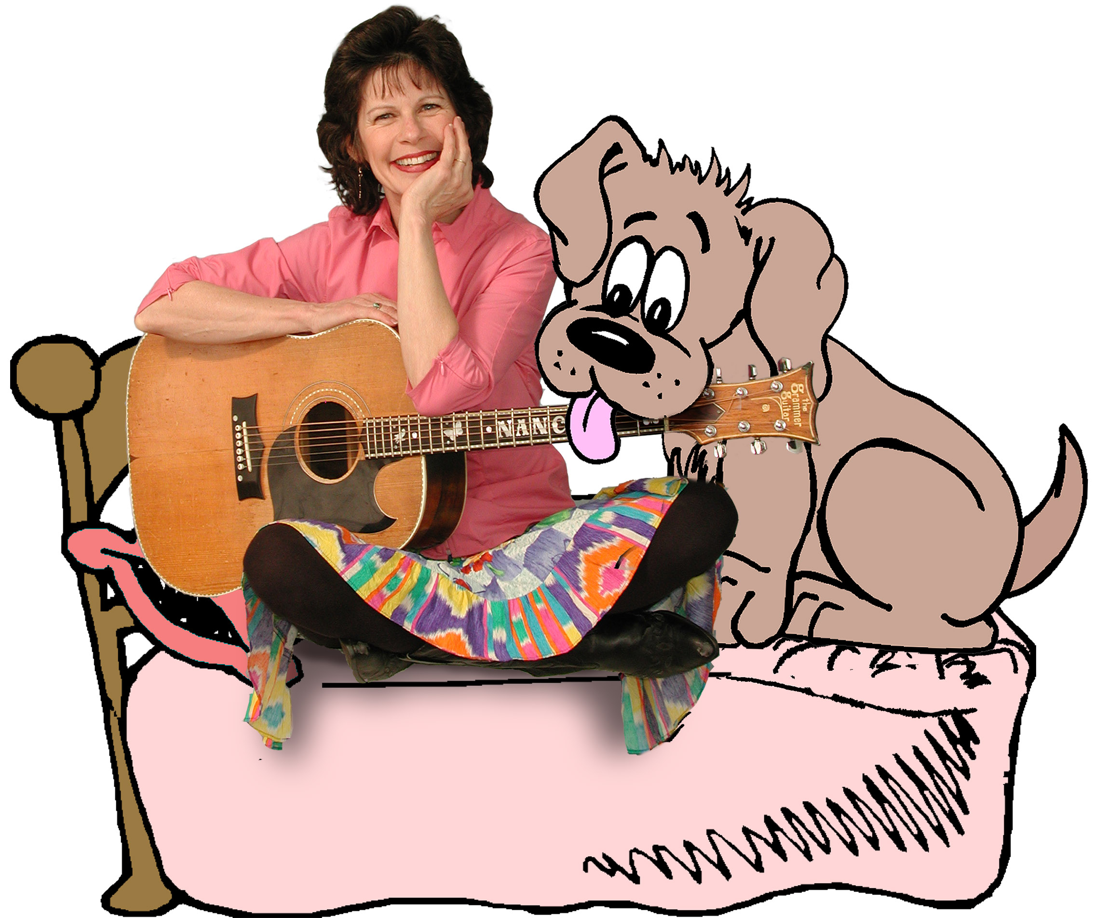
Bedhog Dogs!
and other pet songs...

Family Concert with Nancy Stewart
(Type your concert details here)
www.Nancymusic.com

