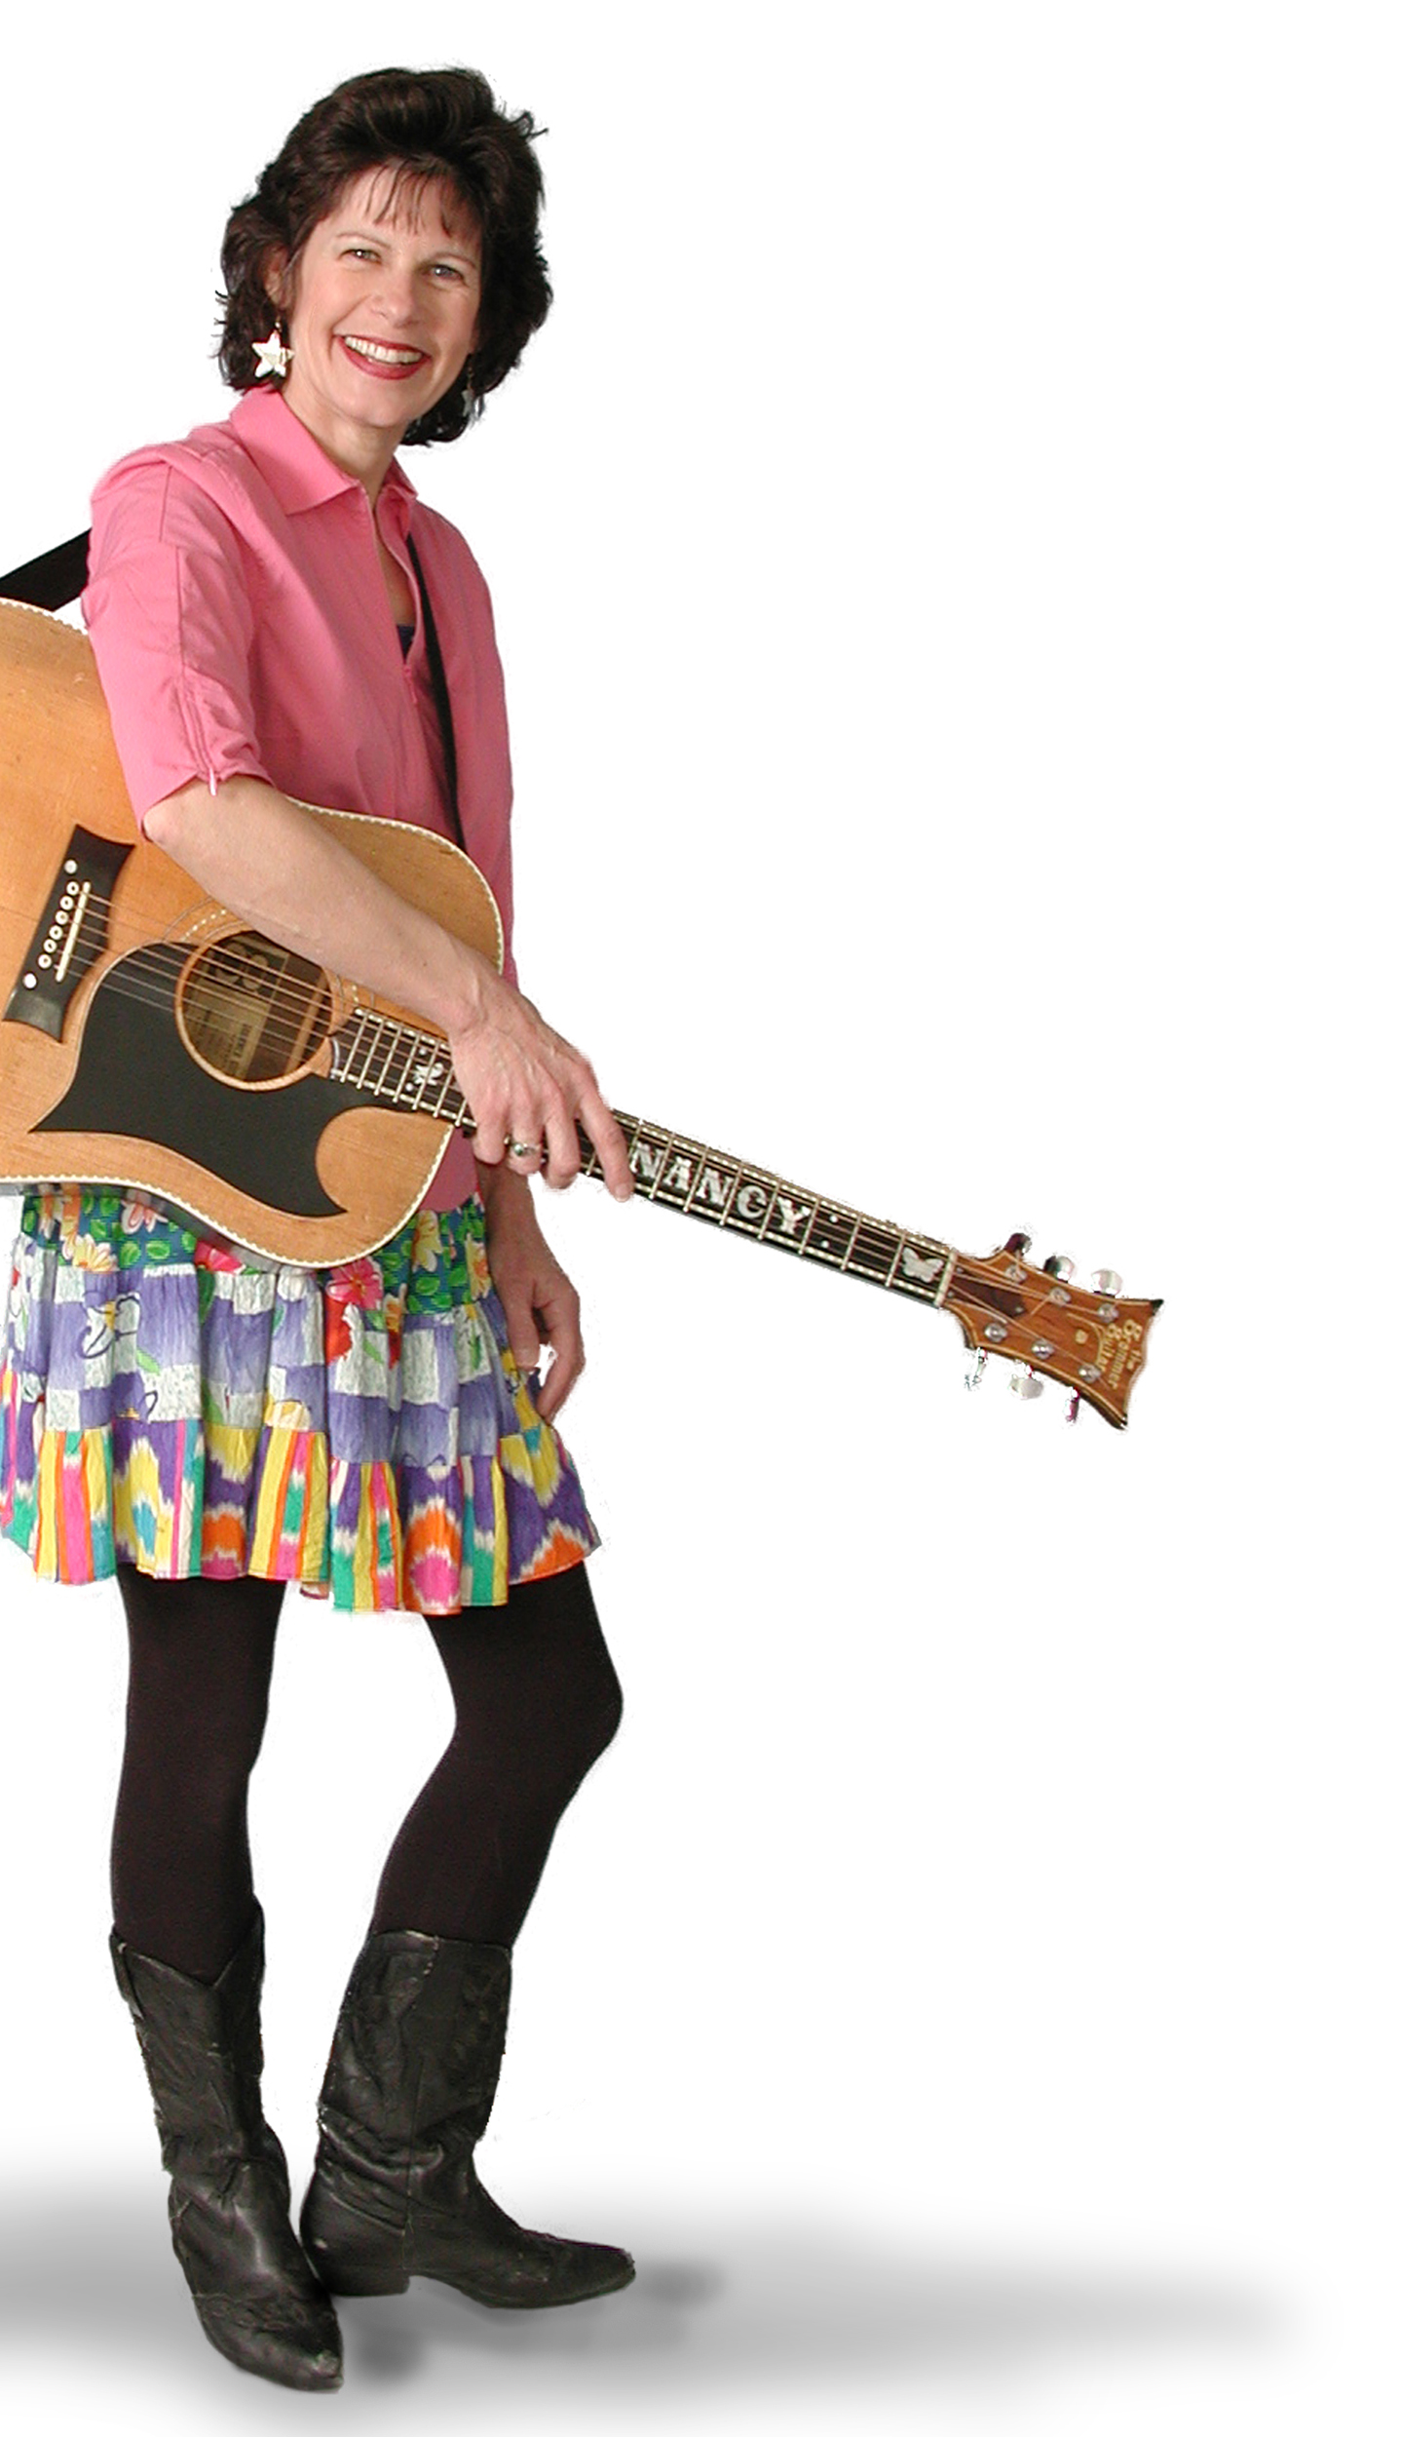

Click here to add other details, like concert sponsor or where to call for information. Delete text if you don’t need any more information.
Family Concert!
Click here to type in date, time, and location.
Nancy Stewart

